

MID TERM REPORT ON

IOT Based Automatic Vehicle Accident Detection and Rescue System

# Submitted by: Submitted To:

### **Sachin Kumar(171500274) Mr. Amir Khan**

**Kartik Srivastava(1715000156) Technical Trainer**

**Pravendra Kumar(171500236)**

**Course: B.tech**

**Branch: CSE Section : E**

**INDEX**

**ABSTRACT 3**

**INTRODUCTION 4**

**EXISTING SYSTEM 5**

**PROPOSED SYSTEM 5**

**HARDWARE DESCRIPTION 6**

* 1. **NODEMCU: 6**

**2.BREAD BOARD: 6**

**3. ACCELEROMETER SENSOR: 6**

**4. BUZZER : 7**

**5.LED(Light-emitting diode) : 7**

**6.CODE : 8**

**CONCLUSION : 9**

**FUTUER SCOPE : 9**

* + **WEBSITES: 9**

## 

## ABSTRACT

The Rapid growth of technology and infrastructure has made our lives easier. The advent of technology has also increased the traffic hazards and the road accidents take place frequently which causes huge loss of life and property because of the poor emergency facilities. Our project will provide an optimum solution to this draw back. An accelerometer can be used in a car alarm application so that dangerous driving can be detected. It can be used as a crash or rollover detector of the vehicle during and after a crash. With signals from an accelerometer, a severe accident can be recognised. According to this project when a vehicle meets with an accident immediately Vibration sensor will detect the signal or if a car rolls over, and Micro electro mechanical system (MEMS) sensor will detects the signal and sends it to ARM controller. Microcontroller sends the alert message through the GSM MODEM including the location to police control room or a rescue team. So the police can immediately trace the location through the GPS MODEM, after receiving the information. Then after conforming the location necessary action will be taken. If the person meets with a small accident or if there is no serious threat to anyone`s life, then the alert message can be terminated by the driver by a switch provided in order to avoid wasting the valuable time of the medical rescue team. This paper is useful in detecting the accident precisely by means of both vibration sensor and Micro electro Mechanical system (MEMS) or accelerometer. As there is a scope for improvement and as a future implementation we can add a wireless webcam for capturing the images which will help in providing driver's assistance.

## INTRODUCTION

The high demand of automobiles has also increased the traffic hazards and the road accidents. Life of the people is under high risk. This is because of the lack of best emergency facilities available in our country. An automatic alarm device for vehicle accidents is introduced in this paper. This design is a system which can detect accidents in significantly less time and sends the basic information to first aid centre within a few seconds covering geographical coordinates, the time and angle in which a vehicle accident had occurred. This alert message is sent to the rescue team in a short time, which will help in saving the valuable lives. A Switch is also provided in order to terminate the sending of a message in rare case where there is no casualty, this can save the precious time of the medical rescue team. When the accident occurs the alert message is sent automatically to the rescue team and to the police station. The message is sent through the GSM module and the location of the accident is detected with the help of the GPS module. The accident can be detected precisely with the help of both Micro electro mechanical system (MEMS) sensor and vibration sensor. The Angle of the rolls over of the car can also be known by the message through the MEMS sensor. This application provides the optimum solution to poor emergency facilities provided to the roads accidents in the most feasible way.

## EXISTING SYSTEM

The existing system only use the information about the vehicle’s vibrating measurements to detect the accident and that is doesn’t work in network less areas.And after occurrence of the accident, controlling of traffic takes high time. This drawback can be overcome by proposed system.

Disadvantage:

**1.** It has low reliability

**2.** Poor control system

## PROPOSED SYSTEM

The main principle of the project is the detection and rescue management. The system is on and initialization. If vehicle is normal, no messages has been sent to rescue team. And the temperature level of the driver is monitored in all the time, if it reaches the threshold level then the action has been taken automatically. Whenever accident occurred, the MEMS sensor, tilt sensor and fire sensor detects the accident happened with vehicle. The controller get the input from sensors and send the accident alert information to road side unit and then message is send to the rescue team and also WIFI and GPS finds location of the vehicle and that also send to the rescue team. It will facilitate connectivity to the nearest hospital and provide medical help through IOT technology.

Advantages:

**1.** Fast recovery and quick process.

**2.** Monitor all hazards and threats in both network coverage and no network areas.

**3.** Wireless monitoring and user friendly.

## HARDWARE DESCRIPTION

* 1. **NODEMCU:**

NodeMCU is an open-source firmware and development kit that helps you to prototype or build IoT product. It includes firmware which runs on the ESP8266 Wi-Fi SoC from Espressif Systems, and hardware which is based on the ESP-12 module. The firmware uses the Lua scripting language. It is based on the eLua project, and built on the Espressif Non-OS SDK for ESP8266. MCU stands for MicroController Unit - which really means it is a computer on a single chip. A microcontroller contains one or more CPUs (processor cores) along with memory and programmable input/output peripherals. They are used to automate automobile engine control, implantable medical devices, remote controls, office machines, appliances, power tools, toys etc.

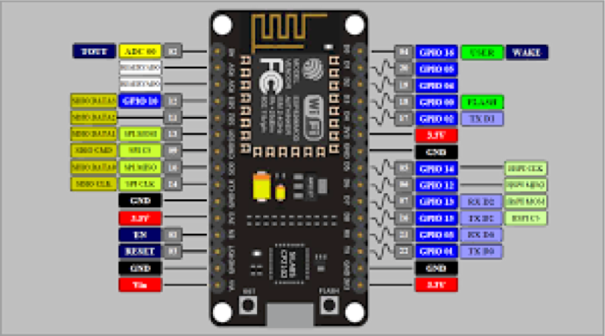

**2.BREAD BOARD:**

A thin plastic board used to hold electronic components (transistors, resistors, chips, etc.) that are wired together. Used to develop prototypes of electronic circuits.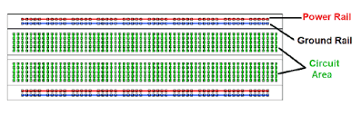

**3. ACCELEROMETER SENSOR:**

As its name suggests, the accelerometer sensor can be used to measure the acceleration exerted upon the sensor. Usually the acceleration is given in two or three axis-vector components that make up the sum/net acceleration.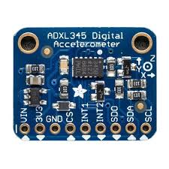

**4. BUZZER :**

A buzzer or beeper is an [audio](https://en.wikipedia.org/wiki/Sound) signalling device , which may be [mechanical](https://en.wikipedia.org/wiki/Machine), [electromechanical](https://en.wikipedia.org/wiki/Electromechanics), or [piezoelectric](https://en.wikipedia.org/wiki/Piezoelectricity) (piezo for short). Typical uses of buzzers and beepers include [alarm devices](https://en.wikipedia.org/wiki/Alarm_devices), [timers](https://en.wikipedia.org/wiki/Timer), and confirmati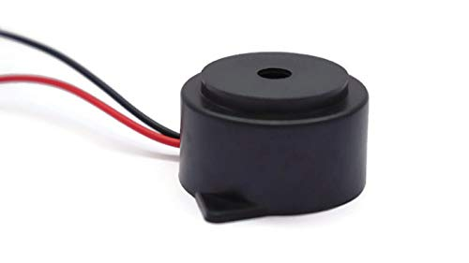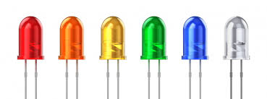on of user input such as a mouse click or keystroke.

**5.LED(Light-emitting diode) :**

A **light-emitting diode** (**LED**) is a [semiconductor](https://en.wikipedia.org/wiki/Semiconductor) [light source](https://en.wikipedia.org/wiki/Light_source) that emits light when [current](https://en.wikipedia.org/wiki/Electric_current) flows through it. [Electrons](https://en.wikipedia.org/wiki/Electron) in the semiconductor recombine with [electron holes](https://en.wikipedia.org/wiki/Electron_hole), releasing energy in the form of [photons](https://en.wikipedia.org/wiki/Photon). The color of the light (corresponding to the energy of the photons) is determined by the energy required for electrons to cross the [band gap](https://en.wikipedia.org/wiki/Band_gap) of the semiconductor.

**6**.**CODE** :

/* Interface Accelerometer with NodeMCU

* By TheCircuit

*/

const int xPin=A0; //X-axis of the Accelerometer

void setup()

{

// initialize serial .communication at 9600 bps:

Serial.begin(9600);

}

void loop()

{

int x =analogRead(xPin);

delay(100);

Serial.print("X-Axis : ");

Serial.println(x);

}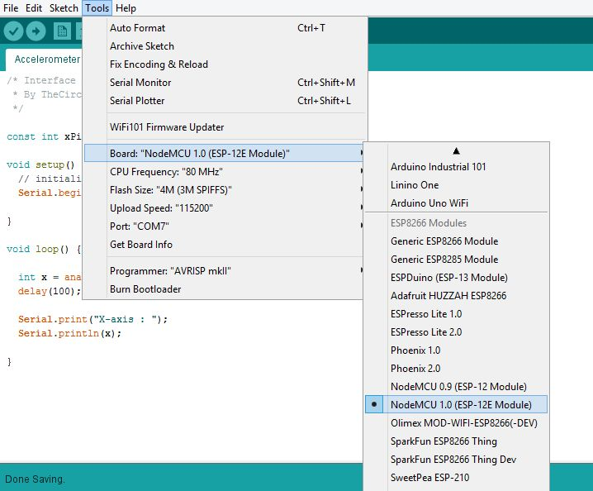

## CONCLUSION :

The proposed system deals with the accident alerting and detection. Arduino is the heart of the system which helps in transferring the message to different devices in the system. Vibration sensor will be activated when the accident occurs and the information is transferred to the registered number through GSM module. Using GPS the location can be sent through tracking system to cover the geographical coordinates over the area. The accident can be detected by a Accelerometer sensor which is used as major module in the system

## FUTUER SCOPE :

The proposed system deals with the detection of the accidents. But this can be extended by providing medication to the victims at the accident spot. By increasing the technology we can also avoid accidents by providing alerts systems that can stop the vehicle to overcome the accidents.

* + **WEBSITES:**

1. <https://www.nodemcu.com/index_en.html>
2. <https://en.wikipedia.org/wiki/Accelerometer>